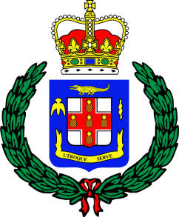

Constabulary Communications Network
101-105 Old Hope Road
Kingston 6
Tel: (876) 978-2214
(876) 927-4427
Email: ccnops@jcf.gov.jm

Jamaica Constabulary Force
We Serve, Protect and Reassure

PRESS RELEASE

For immediate release

PAINTER SLAPPED WITH SEVERAL CHARGES FOLLOWING ABDUCTION

December 18, 2025- Twenty-four-year-old painter Antwan Blackwood of Amylls Drive, Red Hills, Kingston, has been slapped with several charges in relation to an incident that occurred in Woodburn district, Yallahs, St. Thomas, on Saturday, January 25.

He has been charged with Abduction, Robbery with Aggravation, Grievous Sexual Assault, Assault at Common Law, Assault with Intent to Rape, Possession of Identity Information, Unauthorized Access to Computer Data and Simple Larceny.

Reports from the Morant Bay Police are that at about 7:30 p.m., Blackwood and his co-accused, Anthony Graham, who was previously charged, forced a woman into the back of a motor vehicle and drove to a densely vegetated area. While at the location, they robbed the woman of an iPhone, a Samsung cellular phone, and her debit card. The duo also sexually assaulted the woman before demanding the pin to her debit card and then left her at the location. The men then travelled to an Automated Teller Machine and withdrew $24,000 JMD.

Following the ordeal, a report was made to the police and an investigation launched.

Blackwood was subsequently charged on Wednesday, December 18, after he was taken into custody in relation to a separate incident. A court date is being finalised for him.
-30-

